**Assignment 3 : Retrieve data using Group By clause**

**Sample table1:Department**

create table Department(

dept_id int not null primary key,

dept_name nvarchar(50) not null)

INSERT INTO Department VALUES (101,'PRODUCTION')

INSERT INTO Department VALUES (102,'FINANCE')

INSERT INTO Department VALUES (103,'MARKETING')

INSERT INTO Department VALUES (104,'ACCOUNTING')

**Sample table2: Employee**

create table Employee(

emp_id int not null primary key,

dept_id int not null foreign key(dept_id) references Department(dept_id),

mngr_id int not null,

emp_name nvarchar(50) not null,

salary money not null)

INSERT INTO Employee VALUES (1,102,2,'VIKAS',8000)

INSERT INTO Employee VALUES (2,103,3,'VIJAY',15000)

INSERT INTO Employee VALUES (3,104,5,'RAJ',11500)

INSERT INTO Employee VALUES (4,102,2,'JOSH',3000)

INSERT INTO Employee VALUES (5,103,4,'PARTH',10000)

INSERT INTO Employee VALUES (6,103,4,'SMEET',28000)

INSERT INTO Employee VALUES (7,101,1,'VIMAL',25500)

INSERT INTO Employee VALUES (8,102,2,'VISVAS',7000)

INSERT INTO Employee VALUES (9,101,1,'PRAKASH',12850)

INSERT INTO Employee VALUES (10,103,3,'JOHN',9075)

INSERT INTO Employee VALUES (11,104,5,'HITESH',11000)

INSERT INTO Employee VALUES (12,103,3,'MAHESH',6950)

INSERT INTO Employee VALUES (13,102,2,'MOHAN',17500)

INSERT INTO Employee VALUES (14,101,1,'KUSH',13500)

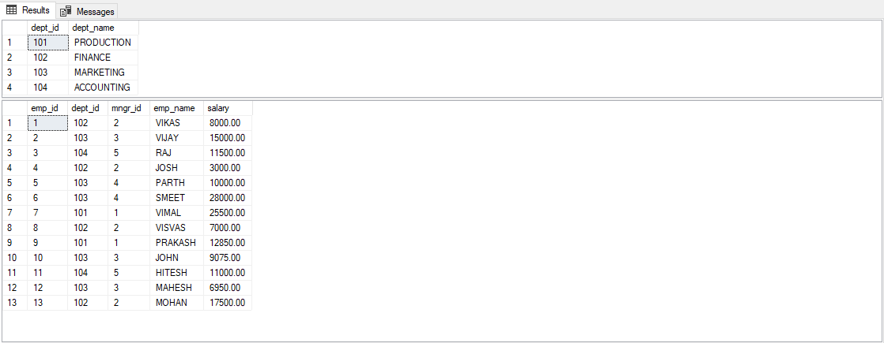

**1. write a SQL query to find Employees who have the biggest salary in their Department**

select emp_name,maxsalemp.salary from Employee E

inner join

(select dept_id, MAX(salary) AS salary

from Employee

group by dept_id)maxsalemp

on E.dept_id = maxsalemp.dept_id and E.salary = maxsalemp.salary

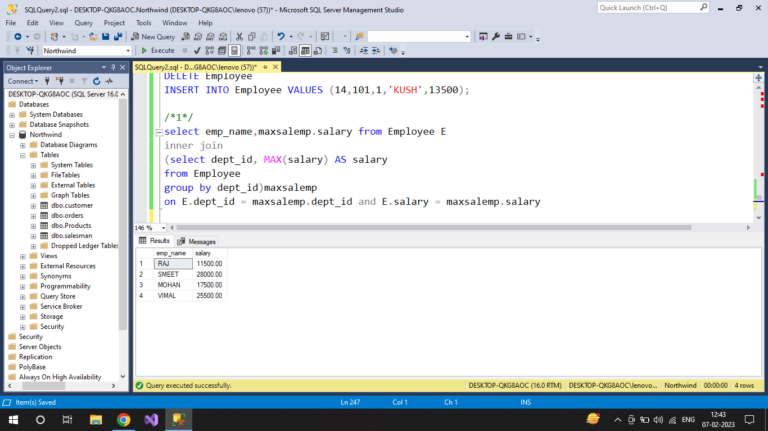

**2. write a SQL query to find Departments that have less than 3 people in it**

select d.dept_name, count(e.emp_name) as employeno

from Department d

join Employee e

on d.dept_id = e.dept_id

group by d.dept_name

having count(e.emp_name) < 3

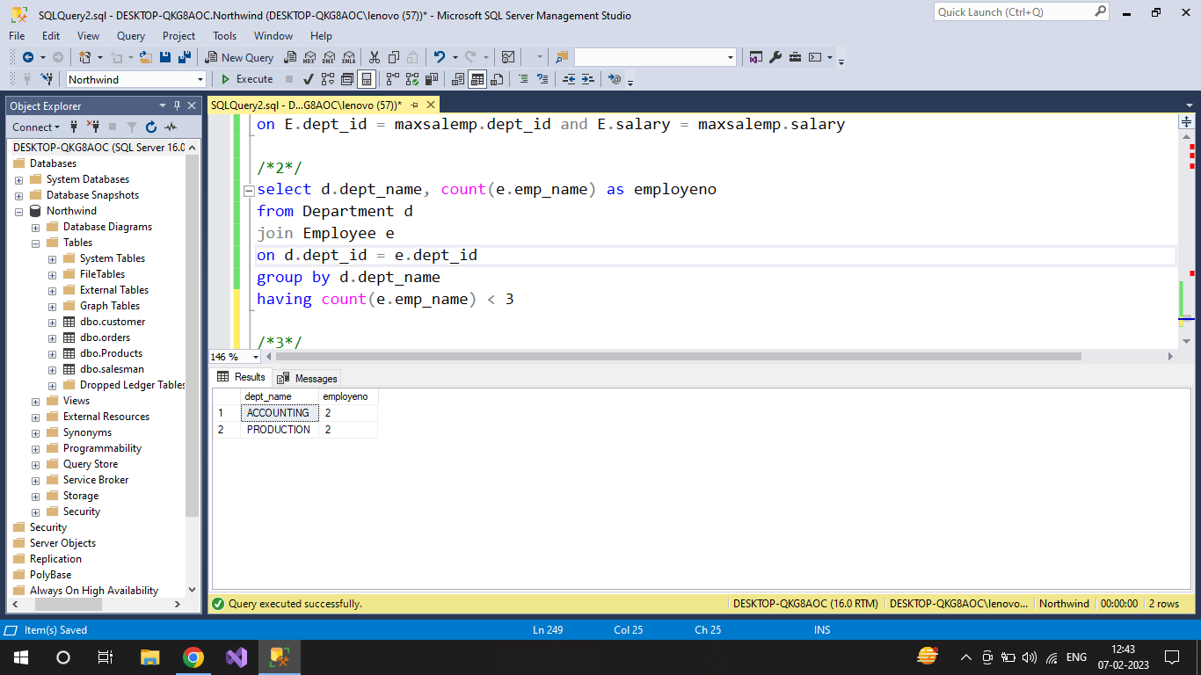

**3. write a SQL query to find All Department along with the number of people there**

select d.dept_name, count(e.emp_name) as employeno

from Department d

join Employee e

on d.dept_id = e.dept_id

group by d.dept_name

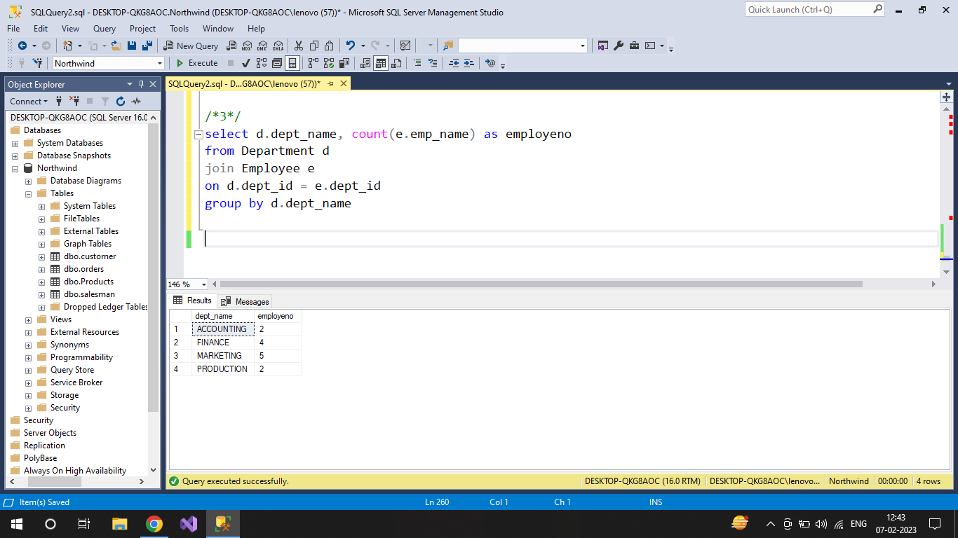

**4. write a SQL query to find All Department along with the total salary there**

select d.dept_name, sum(e.salary) as totalsalary

from Department d

join Employee e

on d.dept_id = e.dept_id

group by d.dept_name

